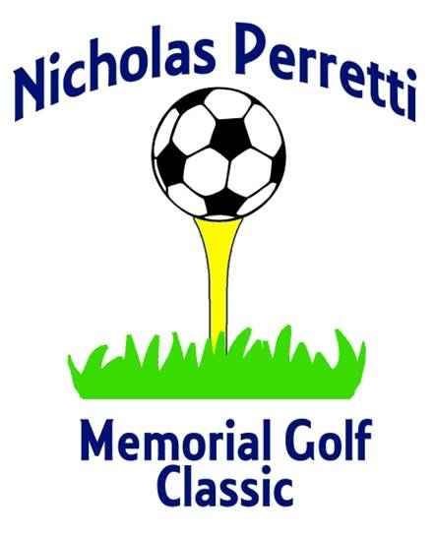
To benefit the Nicholas Steven Perretti
Charitable Trust
Gannon Municipal Golf Course, Lynn MA
Wednesday August 7th 2013 @ 9 am

Tournament Sponsor $1000.00 Dinner Sponsor $300.00
Foursome which includes dinner Split page ad on inside cover of program
Inside front page of cover of program Website advertisement
Website advertisement 18x24 sign
3x8 Banner

Golf Cart Sponsor $250.00 Greens Sponsor $150.00
18X24 sign 18X24 sign
Split page ad on 2nd page of program Logo on back cover of program
Website advertisement Website advertisement

Tee Box Sponsor $200.00 Breakfast Sponsor $250.00
18x24 sign 18X24 sign
Logo on back cover of program Split back ad on inside cover of program
Website advertisement Website advertisement

If you are donating to the auction and or raffle, please list the donated item(s).

Auction(s)______________________________________________

Raffle Item(s)___________________________________________

Please circle your sponsorship if applicable and mail form and check to:

Nicholas Steven Perretti Charitable Trust
c/o Steven Perretti, trustee
481 Buck Island Rd. 16G
West Yarmouth Ma. 02673

Be sure to visit http://www.NickPerrettiFund.com
For more information and to pay online, by using PayPal!

The Nicholas Steven Perretti Charitable Trust is a 501(3) c not-for-profit charitable organization.
Federal Tax ID # 27-6504941

I will attend the Nicholas Perretti Memorial Golf Classic ______.

I would like to attend the dinner only ____ ($45.00)

Please register me as: 1__ 2__ 3__ player(s) @ $135.00 per Player

or a Foursome __ $540.00

Name _______________________________ Tel.#_________________ Email_________________

Address ____________________________ City________________State____Zip code__________

My partners/foursome will be:

Name:________________________________ Name:__________________________________

Name:________________________________ Name:__________________________________

____ I cannot attend the Nicholas Perretti Memorial Golf Classic but would like to make a
Contribution to the Nicholas Steven Perretti Charitable Trust.

Please make check or money order payable to the Nicholas Steven Perretti Charitable Trust.

All proceeds benefit the Nicholas Steven Perretti Charitable Trust

Schedule of Events  8:00 AM Continental Breakfast  9:00 AM Shotgun Start  2:30-3:30 PM Cocktail Hour  Silent Auction  Raffle  3:30 PM Dinner/Awards | Each Golf Ticket  Includes:  Continental Breakfast  Player Gift Package  18 Holes of Golf and Cart  Dinner & Awards Ceremony

Please fill out and mail check to:

Nicholas Steven Perretti Charitable Trust
c/o Steven Perretti, trustee
481 Buck Island Rd. 16G
West Yarmouth Ma. 02673

Be sure to visit http://www.NickPerrettiFund.com
For more information and to pay online, by using PayPal!

The Nicholas Steven Perretti Charitable Trust is a 501(3)c not-for-profit charitable organization. Federal Tax ID # 27-6504941

